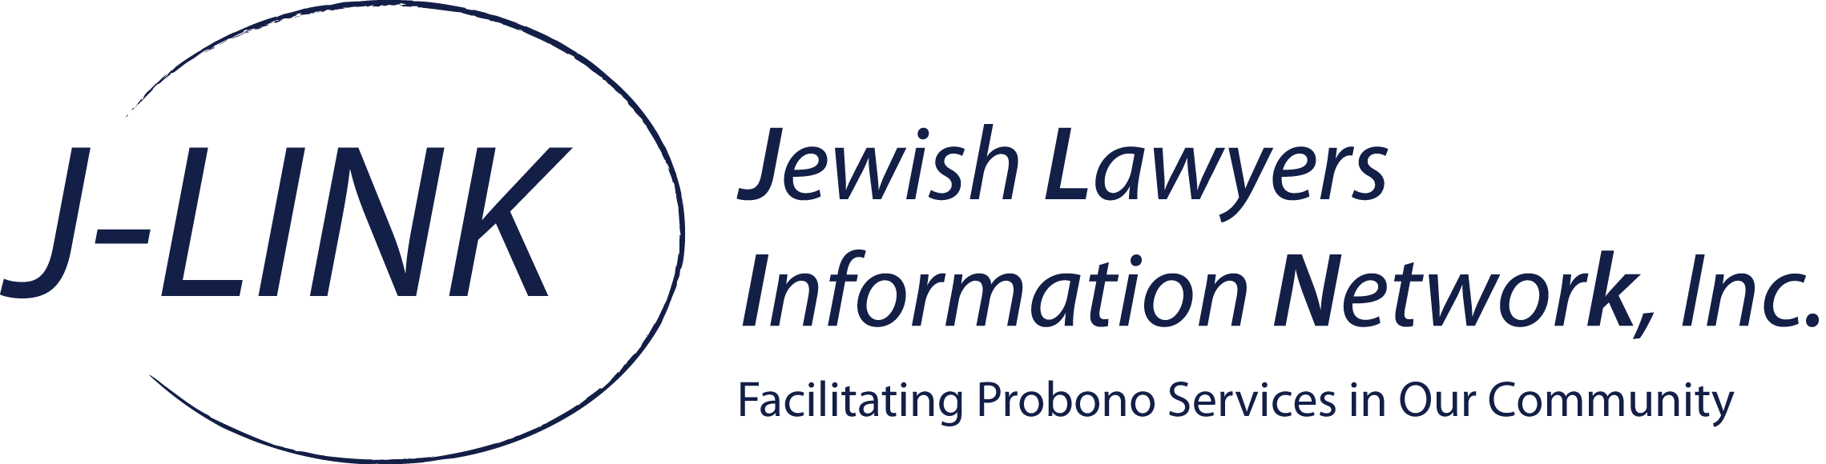

Volunteer/Counselor Guidelines For Sandy Relief Clinic

We believe that by following these guidelines our volunteers will be able to provide an optimal level of service to those in need.
- Please make sure that the J-LINK Intake Form has been completed and signed.
- Please make sure to fill out the bottom of the form indicating the name of the intake counselor.
- At the end of the day please make sure to return all of the forms to us. We will provide you with a copy of the forms for the people you assisted in case follow up is required.
- Please make sure to highlight that this is just a clinic and that you are not creating an attorney/client relationship. It should be clear that J-LINK is not here to provide actual advocacy.
- For the people you assist, we would ask that you accept the responsibility of becoming their case manager. This means, that you will follow up with them to see how they are progressing. In addition, if they are need of additional assistance or guidance in other areas of law you will take ownership of the “case” and make sure they are reaching the right people or by trying to obtain answers for them (generally by finding another J-LINK member to assist).
- If you feel they are need of actual legal advocacy, please let us know. Alternatively, if you feel you can handle their question and can take them on as a client, please let us know as well.
- Please try to keep consultations to no more than 15 minutes. We will try to enforce this time limit as well.
- Treat your client with the same dignity and respect that you would accord any other client.

